Parasomniac
By Matthew Timpanelli
Illustrated by Samuel Purata

Page 1

Open mid dream. A man paralyzed in his bed with howls in the distance getting closer. He makes out a voice calling to him. His fear is crippling and gets so intense as he makes out apparitions coming closer and closer and he wakes up sweating profusely. With the words echoing in his mind from the voice calling him “We are in this together.”

Panel 1: Open mid dream. A man paralyzed in his bed with howls in the distance getting closer.

Ghostly apparitions: Howl.

Panel 2: Voices getting louder and can be vaguely seen hiding in the shadows.

Ghostly apparitions: HOWL!

Panel 3: Man laying in bed and hears someone calling his name.

Ghostly apparitions: Howl!
Woman’s voice: Cole

Panel 4: Close up of the man’s eyes open.

Woman’s voice: Cole

Panel 5: Man sitting up sweating profusely. Man hear’s a voice calling to him over the ghostly howls even though he is still awake.

Ghostly apparitions: Howl!
Woman’s Voice: We are in this together

Page 2

Earlier that day… You see an empty stage as the spotlights go out. The audience can only make out a slight reflection from a microphone stand and a shadowy figure blending into the darkness. A man recites a poem… Each line is accompanied by random flashbacks of the man’s life. Each scene represents a moment which the man is socializing with others. The poem conveys that each interaction was forced and ingenuine.

Panel 1:
Lights go out, you can only see a mic stand and a silhouette of a man standing behind it
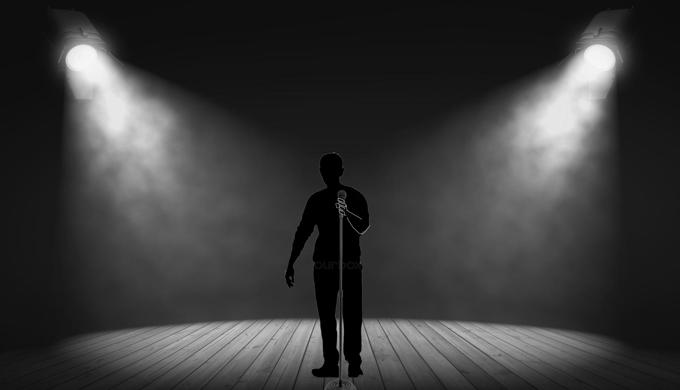

Panel 2:
Different angle of the stage with Cole speaking, flashback panels within a large panel.

Panel 3
Cole is walking down a street with people looking at him.

Cole Narration: You may have seen me around, but that wasn’t really me

Panel 4:
Cole talking to a group of people.

Cole Narration: You and I have had a conversation, but that was not my voice

Panel 5:
Cole having fun with his friend Derwin.

Cole Narration: You and I are close friends for years, but I am lightyears away

Panel 6:
A girl flirting with Cole at a party.
Cole Narration: You may have seen right through me, but I was transparent

Panel 7:
Only narration in blank space

I was never actually there
I am nothing,
and so are you

Page 3

Flash forward to the man going home after the event, laying down in bed reflecting as you see ghosts peeking out of the shadows in the corners and crevices of the room. You then see the man asleep in bed and visibly struggling. The man begins to sweat as you faintly see the form of a woman reaching out to him from the ceiling. “Don’t be afraid” …

Panel 1:
Cole walking home. Still only a silhouette with street lights being the only light.

Panel 2:
Cole on his side in bed.

Cole’s thought bubble: I am nothing…

Panel 3:
Cole is lying on his back in bed with the look of horror on his face.
Ghosts are casting shadows on him as if they are standing at the foot of his bed.

Panel 4:
Cole is beginning to sweat in bed and above him you see the form of a woman floating above him, reaching out to him.

Woman’s Voice: Don’t be afraid

Page 4

The next day the man is struggling at work in the coffee shop as he hasn’t gotten any sleep the night before. Taking orders from people and writing their names incorrectly on cups. Later on break his co-worker/friend asks him if he’s ok because he seems like he’s not all there. Just haven’t gotten much sleep is all. Don’t really want to be here today, or ever for that matter.” His mind drifts off as the panel fast forwards to after work as he’s in the same position as before with his same friend from work. His friend is now talking about his performance the previous night. “Man you really killed it last night. We were all talking about it when you left. You shoulda stuck around.”

Panel 1:
At a coffee shop

Cole: Name?
Female Customer: Dawn

Panel 2:
Cole writing “Yawn” on a coffee cup with droopy eyes, barely awake

Panel 3:
Cole is sweeping up and Derwin is wiping off tables.

Derwin: You ok?
Cole: Just haven’t gotten much sleep.

Panel 4:
They sit down for a break.

Cole: I don’t really want to be here today, or ever really.

{Show daydreaming somehow}

Panel 5:
Cole and Derwin sitting on a train.

Derwin: You killed it last night. Afterwards we were all talking about it.

Panel 6:
Cole fades away from the scene.

Derwin: You shoulda stuck around.

Page 5

In bed again and you see an ominous figure hovering him as he’s drifting off. Zoom in as you see his eyes close. He opens them and he is in another world. Fire is billowing around him in the distance and he is in some sort of labyrinth. He turns around and a woman takes his hand “stay with me, this way” She points down the pathway with her giant sword.

Panel 1:
Cole in bed with a shadowy figure behind him as he is drifting off to sleep.

Panel 2:
Zoomed in at Cole’s eyes closed.

Panel 3:
Cole’s eyes open and he is in another world.

Panel 4:
Cole standing in a labyrinth with fire in the distance.

Panel 5:
A woman takes his hand.

Grace: Stay with me.

Panel 6:
The woman (Grace) points her sword.

Grace: This way!

Page 6

As they attempt to move the man is held back by a flying demon. The woman turns and swings her sword, the demon evades the attack and grabs her hair twisting her head around and the man wakes up suddenly in his bed again. He sits up quickly as he opens his eyes and sees a long strand of hair floating and slowly falling. He reaches up to catch it in his hand and he hears “it’s ok. I’m with you”
He gets up and walks over to his studio where he takes out his watercolor paints and begins to paint the scene from his dream. He begins to draw the woman’s face and he hears her voice again. “We are in this together.”

Panel 1:
A flying demon grabs Cole by the shirt preventing them from leaving.

Panel 2:
The woman turns to swing her sword at the demon but misses as the demon evades the attack.

Panel 3:
The demon grabs on to Grace’s hair which twists her head around

Panel 4:
Cole sitting up in his bed again and sees a lock of hair floating into his hand which is held out

Grace: It’s ok, I’m with you

Panel 5:
Cole grabs some watercolors

Panel 6:
Cole painting a portrait of Grace’s face

Grace’s voice echoing in Cole’s mind: We are in this together.

Page 7

The next day he visits his sister. Her clothing suggests she’s into new age philosophy. They are walking in the woods in a park and he’s explaining his weird dreams to her. She talks about Jungian philosophy and archetypes and tries to interpret his dream. He is fatigued and a bit crazed. The insomnia is taking its toll on his psyche. He takes his hand off his head and turns around and sees a woman pass by and hears “i’m with you”. His sister goes on to say he needs rest and he turns to look but the woman that passed is no longer there. “Did you just…” he begins to say but stops himself and says “nevermind”.

Panel 1:
Cole greets his sister.

Eleanor: Hey lil’ bro. How you holding up?

Panel 2:
Cole and Eleanor walking in the park together.

Cole: I have been having the strangest nightmares.
Eleanor: Are there any distinctive symbols in these dreams?

Panel 3:
Cole puts his hand on his head in distress.

Cole: There is a woman...
Eleanor: Ok. Well, Carl Jung theorized that archetypes are embedded into our consciousness…

Panel 4:
Eleanor continues to ramble on about Jungian dream interpretation… Cole looks up and sees a woman passing them.
Eleanor(small type as if Cole isn’t listening anymore): Those symbols have a general meaning to them but we have to include what they mean to us in the interpretation. Woman’s Voice(auditory hallucination): I’m with you

Panel 5:
Cole turns to see who the girl was that passed by but no one is there.

Eleanor: I suggest keeping a dream journal…
Cole: Did you just...Nevermind…

Page 8

The man and his friends are at the coffee shop sitting and chatting. He is somewhere else in his mind seeing visions of demons and ghosts from his dreams as his friends chat together. One of his friends is scrolling on their phone and turns to the other to show something they found. Hey man check it out your viral. He looks to see a video of his performance from the other night on youtube. Entitled “the man who isnt there” Cut to a different phone showing the same video and then you see the person viewing it resembles the woman from his dreams. She puts her phone down and reflects on what she’s seen and you see in the corners of her room ghosts creeping out and the shadow of a flying demon outside her window.

Panel 1:
At the coffee shop sitting with Derwin and his artsy friends who are talking amongst each other.

Panel 2:
Cole seeing demons/ghosts amongst the shadows in the background behind his friends.

Panel 3:
One of his friends scrolls on his phone turning to show Derwin what they found.

Panel 4:
Derwin shows the phone to Cole

Derwin: Check it out. You’re viral!

Panel 5:
Cole looking at the phone seeing a video of his performance entitled “The Man Who Isn’t There”

Panel 6:
Cut to a different phone displaying the same video.

Cole (in the video): I am nothing...

Panel 7:
You can see it is a woman watching the video and that it is Grace from Cole’s dream.
See sits there with her head up as if she is thinking, a bit confused. A demon is flying outside her window but she doesn’t see it.

Cole (in the video): ...and so are you

